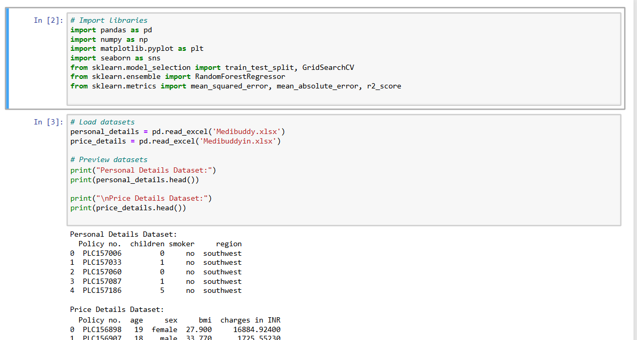

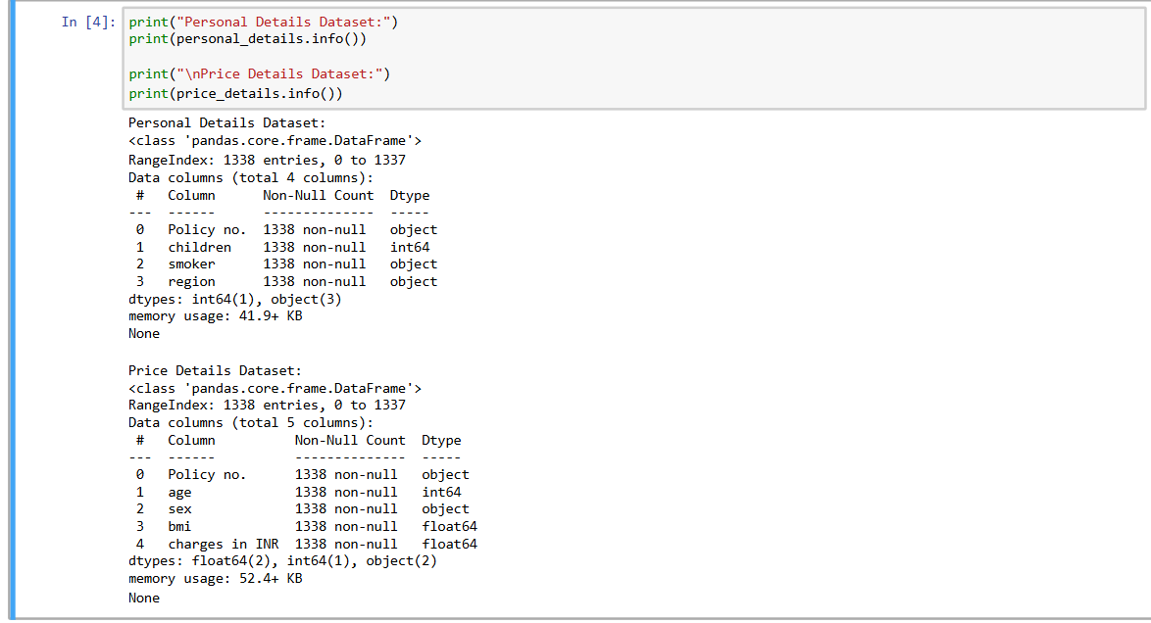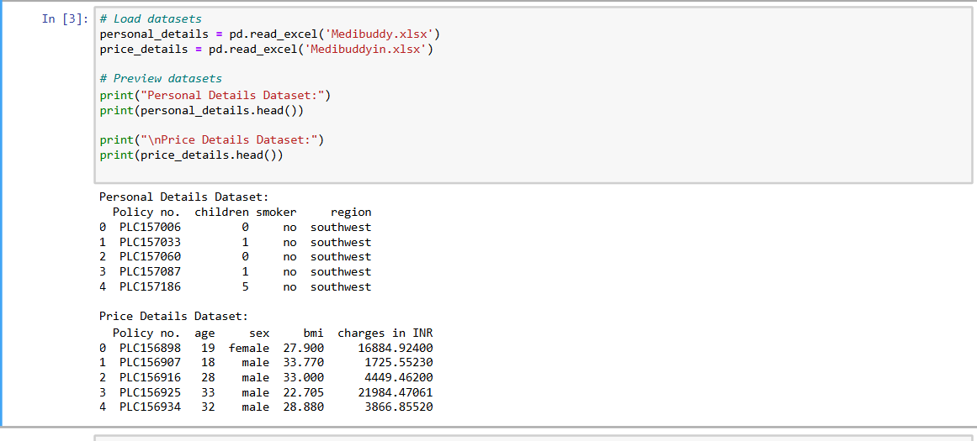

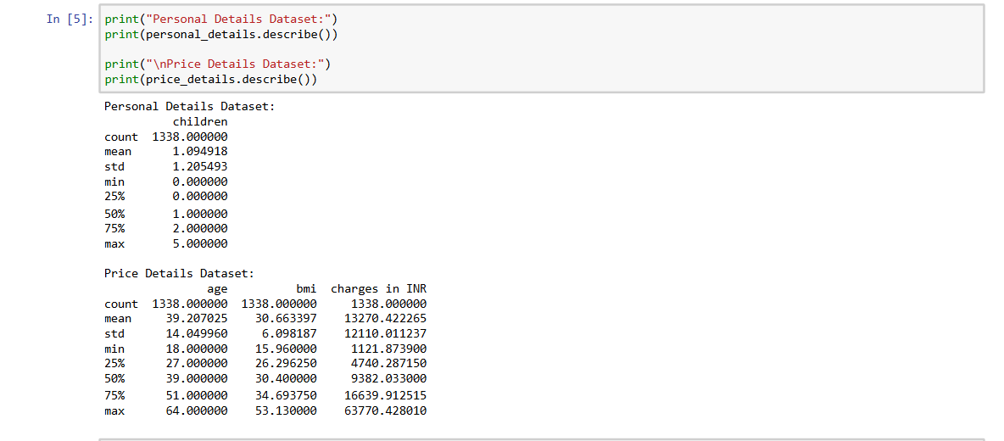

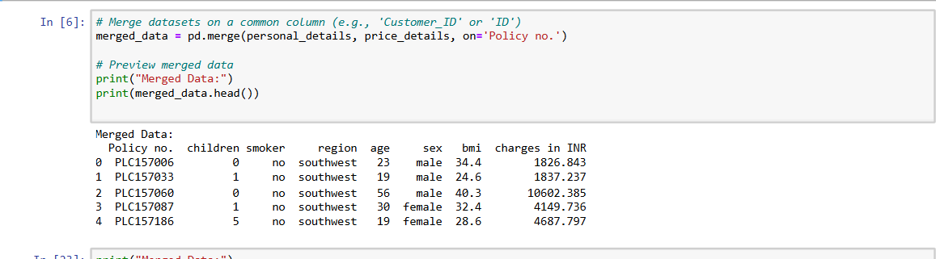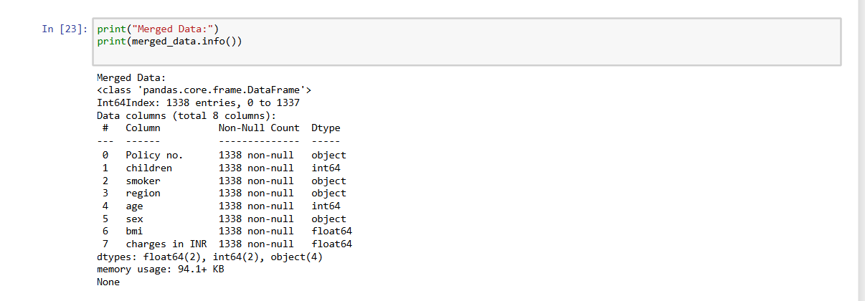

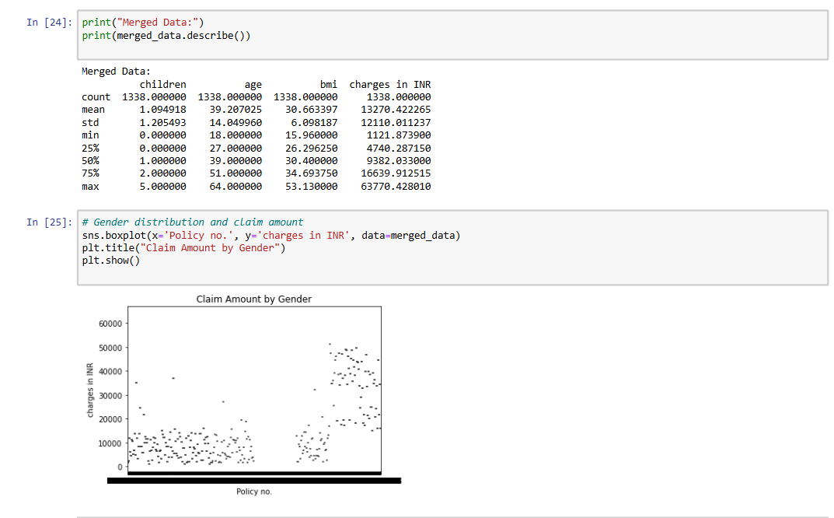

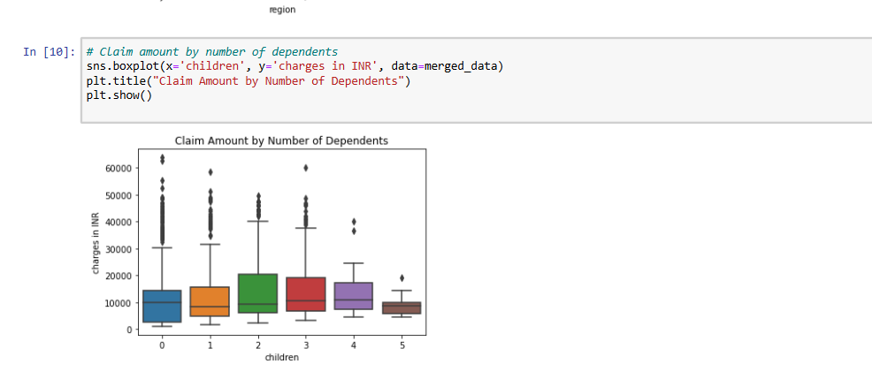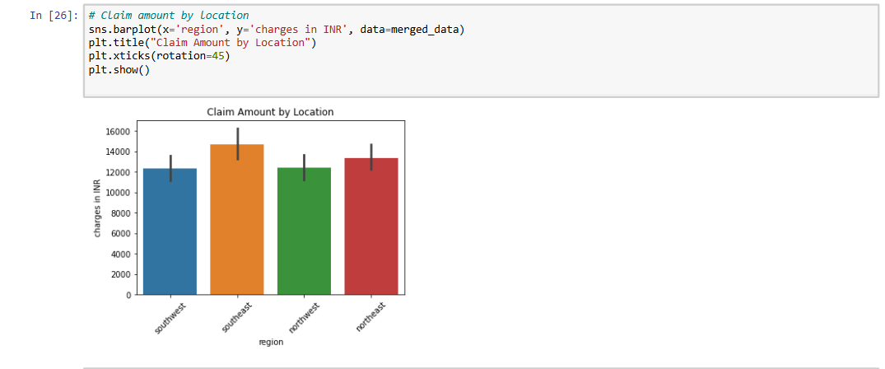

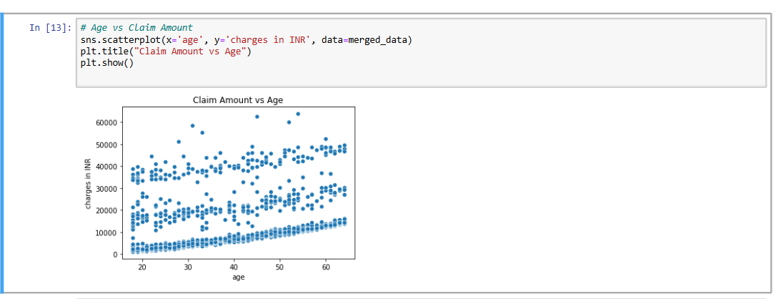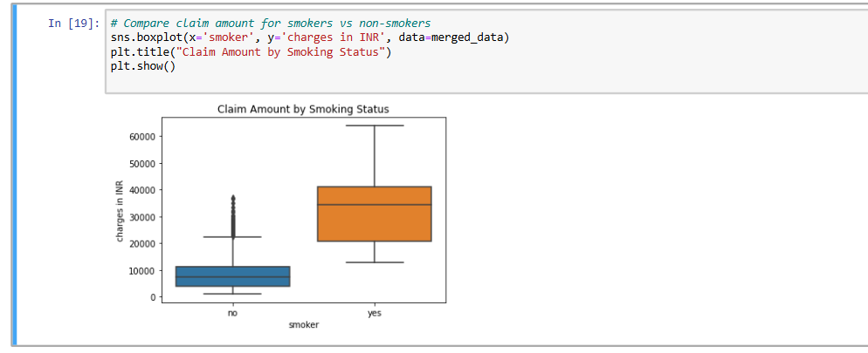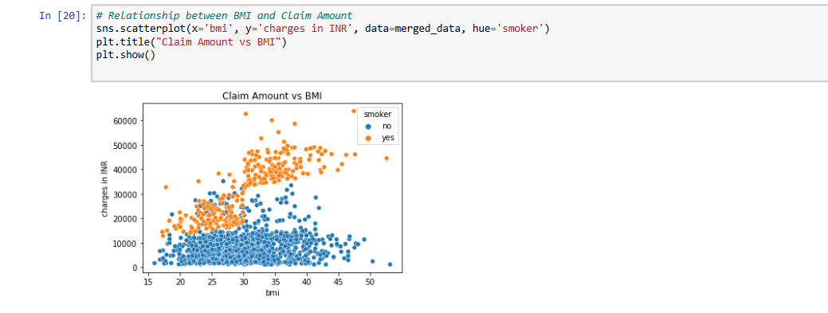

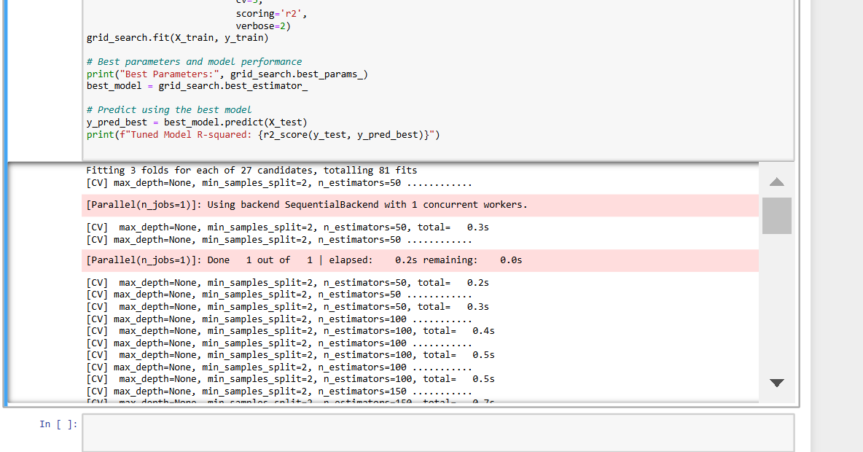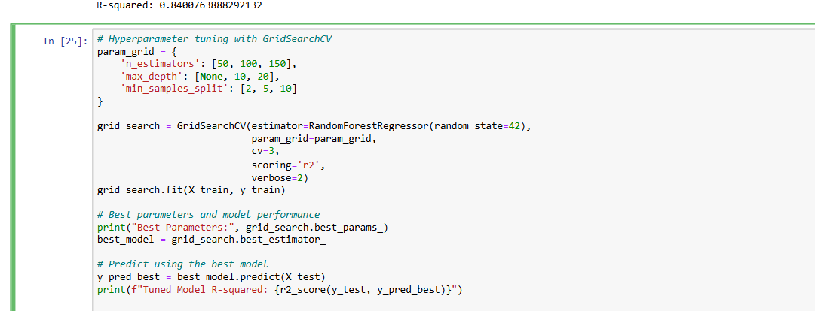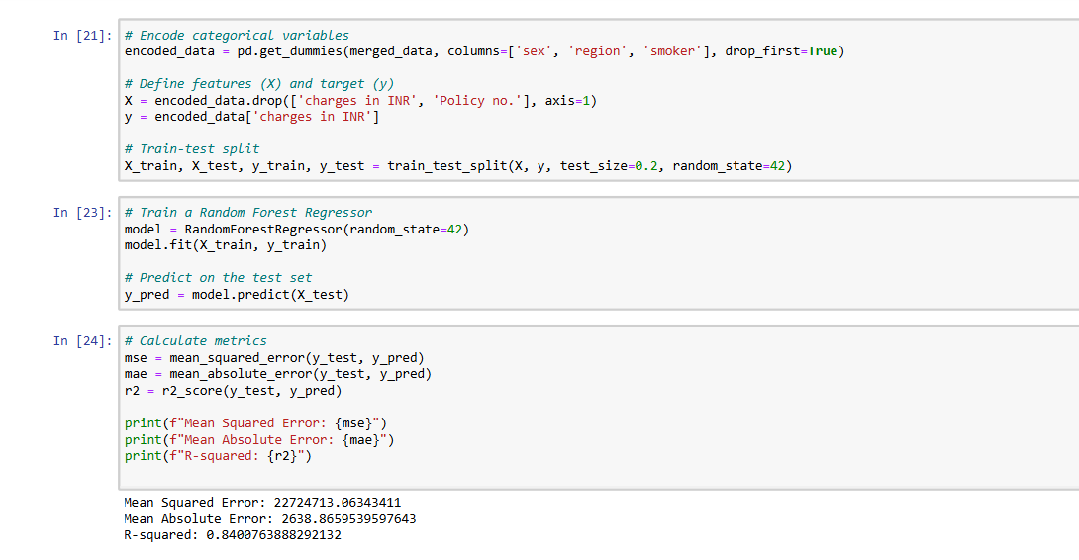Fitting 3 folds for each of 27 candidates, totalling 81 fits

[CV] max_depth=None, min_samples_split=2, n_estimators=50 ............

[Parallel(n_jobs=1)]: Using backend SequentialBackend with 1 concurrent workers.

[CV] max_depth=None, min_samples_split=2, n_estimators=50, total= 0.3s

[CV] max_depth=None, min_samples_split=2, n_estimators=50 ............

[Parallel(n_jobs=1)]: Done 1 out of 1 | elapsed: 0.2s remaining: 0.0si

[CV] max_depth=None, min_samples_split=2, n_estimators=50, total= 0.2s

[CV] max_depth=None, min_samples_split=2, n_estimators=50 ............

[CV] max_depth=None, min_samples_split=2, n_estimators=50, total= 0.3s

[CV] max_depth=None, min_samples_split=2, n_estimators=100 ...........

[CV] max_depth=None, min_samples_split=2, n_estimators=100, total= 0.4s

[CV] max_depth=None, min_samples_split=2, n_estimators=100 ...........

[CV] max_depth=None, min_samples_split=2, n_estimators=100, total= 0.5s

[CV] max_depth=None, min_samples_split=2, n_estimators=100 ...........

[CV] max_depth=None, min_samples_split=2, n_estimators=100, total= 0.5s

[CV] max_depth=None, min_samples_split=2, n_estimators=150 ...........

[CV] max_depth=None, min_samples_split=2, n_estimators=150, total= 0.7s

[CV] max_depth=None, min_samples_split=2, n_estimators=150 ...........

[CV] max_depth=None, min_samples_split=2, n_estimators=150, total= 0.7s

[CV] max_depth=None, min_samples_split=2, n_estimators=150 ...........

[CV] max_depth=None, min_samples_split=2, n_estimators=150, total= 0.7s

[CV] max_depth=None, min_samples_split=5, n_estimators=50 ............

[CV] max_depth=None, min_samples_split=5, n_estimators=50, total= 0.2s

[CV] max_depth=None, min_samples_split=5, n_estimators=50 ............

[CV] max_depth=None, min_samples_split=5, n_estimators=50, total= 0.2s

[CV] max_depth=None, min_samples_split=5, n_estimators=50 ............

[CV] max_depth=None, min_samples_split=5, n_estimators=50, total= 0.2s

[CV] max_depth=None, min_samples_split=5, n_estimators=100 ...........

[CV] max_depth=None, min_samples_split=5, n_estimators=100, total= 0.4s

[CV] max_depth=None, min_samples_split=5, n_estimators=100 ...........

[CV] max_depth=None, min_samples_split=5, n_estimators=100, total= 0.4s

[CV] max_depth=None, min_samples_split=5, n_estimators=100 ...........

[CV] max_depth=None, min_samples_split=5, n_estimators=100, total= 0.4s

[CV] max_depth=None, min_samples_split=5, n_estimators=150 ...........

[CV] max_depth=None, min_samples_split=5, n_estimators=150, total= 0.5s

[CV] max_depth=None, min_samples_split=5, n_estimators=150 ...........

[CV] max_depth=None, min_samples_split=5, n_estimators=150, total= 0.6s

[CV] max_depth=None, min_samples_split=5, n_estimators=150 ...........

[CV] max_depth=None, min_samples_split=5, n_estimators=150, total= 0.6s

[CV] max_depth=None, min_samples_split=10, n_estimators=50 ...........

[CV] max_depth=None, min_samples_split=10, n_estimators=50, total= 0.2s

[CV] max_depth=None, min_samples_split=10, n_estimators=50 ...........

[CV] max_depth=None, min_samples_split=10, n_estimators=50, total= 0.2s

[CV] max_depth=None, min_samples_split=10, n_estimators=50 ...........

[CV] max_depth=None, min_samples_split=10, n_estimators=50, total= 0.2s

[CV] max_depth=None, min_samples_split=10, n_estimators=100 ..........

[CV] max_depth=None, min_samples_split=10, n_estimators=100, total= 0.4s

[CV] max_depth=None, min_samples_split=10, n_estimators=100 ..........

[CV] max_depth=None, min_samples_split=10, n_estimators=100, total= 0.3s

[CV] max_depth=None, min_samples_split=10, n_estimators=100 ..........

[CV] max_depth=None, min_samples_split=10, n_estimators=100, total= 0.4s

[CV] max_depth=None, min_samples_split=10, n_estimators=150 ..........

[CV] max_depth=None, min_samples_split=10, n_estimators=150, total= 0.5s

[CV] max_depth=None, min_samples_split=10, n_estimators=150 ..........

[CV] max_depth=None, min_samples_split=10, n_estimators=150, total= 0.5s

[CV] max_depth=None, min_samples_split=10, n_estimators=150 ..........

[CV] max_depth=None, min_samples_split=10, n_estimators=150, total= 0.5s

[CV] max_depth=10, min_samples_split=2, n_estimators=50 ..............

[CV] max_depth=10, min_samples_split=2, n_estimators=50, total= 0.2s

[CV] max_depth=10, min_samples_split=2, n_estimators=50 ..............

[CV] max_depth=10, min_samples_split=2, n_estimators=50, total= 0.2s

[CV] max_depth=10, min_samples_split=2, n_estimators=50 ..............

[CV] max_depth=10, min_samples_split=2, n_estimators=50, total= 0.2s

[CV] max_depth=10, min_samples_split=2, n_estimators=100 .............

[CV] max_depth=10, min_samples_split=2, n_estimators=100, total= 0.5s

[CV] max_depth=10, min_samples_split=2, n_estimators=100 .............

[CV] max_depth=10, min_samples_split=2, n_estimators=100, total= 0.4s

[CV] max_depth=10, min_samples_split=2, n_estimators=100 .............

[CV] max_depth=10, min_samples_split=2, n_estimators=100, total= 0.4s

[CV] max_depth=10, min_samples_split=2, n_estimators=150 .............

[CV] max_depth=10, min_samples_split=2, n_estimators=150, total= 0.5s

[CV] max_depth=10, min_samples_split=2, n_estimators=150 .............

[CV] max_depth=10, min_samples_split=2, n_estimators=150, total= 0.5s

[CV] max_depth=10, min_samples_split=2, n_estimators=150 .............

[CV] max_depth=10, min_samples_split=2, n_estimators=150, total= 0.5s

[CV] max_depth=10, min_samples_split=5, n_estimators=50 ..............

[CV] max_depth=10, min_samples_split=5, n_estimators=50, total= 0.2s

[CV] max_depth=10, min_samples_split=5, n_estimators=50 ..............

[CV] max_depth=10, min_samples_split=5, n_estimators=50, total= 0.2s

[CV] max_depth=10, min_samples_split=5, n_estimators=50 ..............

[CV] max_depth=10, min_samples_split=5, n_estimators=50, total= 0.2s

[CV] max_depth=10, min_samples_split=5, n_estimators=100 .............

[CV] max_depth=10, min_samples_split=5, n_estimators=100, total= 0.3s

[CV] max_depth=10, min_samples_split=5, n_estimators=100 .............

[CV] max_depth=10, min_samples_split=5, n_estimators=100, total= 0.4s

[CV] max_depth=10, min_samples_split=5, n_estimators=100 .............

[CV] max_depth=10, min_samples_split=5, n_estimators=100, total= 0.4s

[CV] max_depth=10, min_samples_split=5, n_estimators=150 .............

[CV] max_depth=10, min_samples_split=5, n_estimators=150, total= 0.5s

[CV] max_depth=10, min_samples_split=5, n_estimators=150 .............

[CV] max_depth=10, min_samples_split=5, n_estimators=150, total= 0.5s

[CV] max_depth=10, min_samples_split=5, n_estimators=150 .............

[CV] max_depth=10, min_samples_split=5, n_estimators=150, total= 0.5s

[CV] max_depth=10, min_samples_split=10, n_estimators=50 .............

[CV] max_depth=10, min_samples_split=10, n_estimators=50, total= 0.1s

[CV] max_depth=10, min_samples_split=10, n_estimators=50 .............

[CV] max_depth=10, min_samples_split=10, n_estimators=50, total= 0.2s

[CV] max_depth=10, min_samples_split=10, n_estimators=50 .............

[CV] max_depth=10, min_samples_split=10, n_estimators=50, total= 0.2s

[CV] max_depth=10, min_samples_split=10, n_estimators=100 ............

[CV] max_depth=10, min_samples_split=10, n_estimators=100, total= 0.3s

[CV] max_depth=10, min_samples_split=10, n_estimators=100 ............

[CV] max_depth=10, min_samples_split=10, n_estimators=100, total= 0.3s

[CV] max_depth=10, min_samples_split=10, n_estimators=100 ............

[CV] max_depth=10, min_samples_split=10, n_estimators=100, total= 0.3s

[CV] max_depth=10, min_samples_split=10, n_estimators=150 ............

[CV] max_depth=10, min_samples_split=10, n_estimators=150, total= 0.5s

[CV] max_depth=10, min_samples_split=10, n_estimators=150 ............

[CV] max_depth=10, min_samples_split=10, n_estimators=150, total= 0.5s

[CV] max_depth=10, min_samples_split=10, n_estimators=150 ............

[CV] max_depth=10, min_samples_split=10, n_estimators=150, total= 0.5s

[CV] max_depth=20, min_samples_split=2, n_estimators=50 ..............

[CV] max_depth=20, min_samples_split=2, n_estimators=50, total= 0.2s

[CV] max_depth=20, min_samples_split=2, n_estimators=50 ..............

[CV] max_depth=20, min_samples_split=2, n_estimators=50, total= 0.2s

[CV] max_depth=20, min_samples_split=2, n_estimators=50 ..............

[CV] max_depth=20, min_samples_split=2, n_estimators=50, total= 0.2s

[CV] max_depth=20, min_samples_split=2, n_estimators=100 .............

[CV] max_depth=20, min_samples_split=2, n_estimators=100, total= 0.4s

[CV] max_depth=20, min_samples_split=2, n_estimators=100 .............

[CV] max_depth=20, min_samples_split=2, n_estimators=100, total= 0.4s

[CV] max_depth=20, min_samples_split=2, n_estimators=100 .............

[CV] max_depth=20, min_samples_split=2, n_estimators=100, total= 0.4s

[CV] max_depth=20, min_samples_split=2, n_estimators=150 .............

[CV] max_depth=20, min_samples_split=2, n_estimators=150, total= 0.6s

[CV] max_depth=20, min_samples_split=2, n_estimators=150 .............

[CV] max_depth=20, min_samples_split=2, n_estimators=150, total= 0.6s

[CV] max_depth=20, min_samples_split=2, n_estimators=150 .............

[CV] max_depth=20, min_samples_split=2, n_estimators=150, total= 0.6s

[CV] max_depth=20, min_samples_split=5, n_estimators=50 ..............

[CV] max_depth=20, min_samples_split=5, n_estimators=50, total= 0.2s

[CV] max_depth=20, min_samples_split=5, n_estimators=50 ..............

[CV] max_depth=20, min_samples_split=5, n_estimators=50, total= 0.2s

[CV] max_depth=20, min_samples_split=5, n_estimators=50 ..............

[CV] max_depth=20, min_samples_split=5, n_estimators=50, total= 0.2s

[CV] max_depth=20, min_samples_split=5, n_estimators=100 .............

[CV] max_depth=20, min_samples_split=5, n_estimators=100, total= 0.3s

[CV] max_depth=20, min_samples_split=5, n_estimators=100 .............

[CV] max_depth=20, min_samples_split=5, n_estimators=100, total= 0.3s

[CV] max_depth=20, min_samples_split=5, n_estimators=100 .............

[CV] max_depth=20, min_samples_split=5, n_estimators=100, total= 0.3s

[CV] max_depth=20, min_samples_split=5, n_estimators=150 .............

[CV] max_depth=20, min_samples_split=5, n_estimators=150, total= 0.5s

[CV] max_depth=20, min_samples_split=5, n_estimators=150 .............

[CV] max_depth=20, min_samples_split=5, n_estimators=150, total= 0.5s

[CV] max_depth=20, min_samples_split=5, n_estimators=150 .............

[CV] max_depth=20, min_samples_split=5, n_estimators=150, total= 0.5s

[CV] max_depth=20, min_samples_split=10, n_estimators=50 .............

[CV] max_depth=20, min_samples_split=10, n_estimators=50, total= 0.2s

[CV] max_depth=20, min_samples_split=10, n_estimators=50 .............

[CV] max_depth=20, min_samples_split=10, n_estimators=50, total= 0.2s

[CV] max_depth=20, min_samples_split=10, n_estimators=50 .............

[CV] max_depth=20, min_samples_split=10, n_estimators=50, total= 0.2s

[CV] max_depth=20, min_samples_split=10, n_estimators=100 ............

[CV] max_depth=20, min_samples_split=10, n_estimators=100, total= 0.4s

[CV] max_depth=20, min_samples_split=10, n_estimators=100 ............

[CV] max_depth=20, min_samples_split=10, n_estimators=100, total= 0.4s

[CV] max_depth=20, min_samples_split=10, n_estimators=100 ............

[CV] max_depth=20, min_samples_split=10, n_estimators=100, total= 0.4s

[CV] max_depth=20, min_samples_split=10, n_estimators=150 ............

[CV] max_depth=20, min_samples_split=10, n_estimators=150, total= 0.5s

[CV] max_depth=20, min_samples_split=10, n_estimators=150 ............

[CV] max_depth=20, min_samples_split=10, n_estimators=150, total= 0.5s

[CV] max_depth=20, min_samples_split=10, n_estimators=150 ............

[CV] max_depth=20, min_samples_split=10, n_estimators=150, total= 0.5s

[Parallel(n_jobs=1)]: Done 81 out of 81 | elapsed: 30.4s finished

Best Parameters: {'max_depth': 10, 'min_samples_split': 10, 'n_estimators': 100}

Tuned Model R-squared: 0.8494762672732492